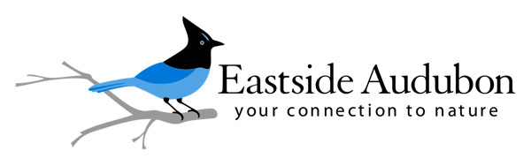
Eastside Audubon is committed to attracting and retaining a diverse board and will honor your experiences, perspectives, and unique identity. Together, we strive to create and maintain a working environment that is inclusive, equitable and welcoming.

Position Title: Education Chair
Purpose: The education chair is a member of the board of directors and serves Eastside Audubon by overseeing an engaging schedule of educational for chapter members and the community.
Key Responsibilities:
- Sets the direction for and oversees the chapter’s education programs, making sure they fit the chapter’s mission and adhere to the chapter’s goals;
- Plans and manages adult education for the chapter: determines education topics, schedules classes, finds and coordinates instructors, and works with Executive Director to publicize events, manages participant registration, class setup and evaluation;
- Supervises the budget for education;
- Partners with other organizations to share resources and reach a wider audience;
- Oversees the following volunteers and committees: adult classes, photo group, program nights, rangers, youth education.
- Supports the board’s birding chair to hold field trip leader classes.
- Assists Volunteer Chairperson to train volunteers.
Education Chair Qualifications: All board members must display a commitment to the organization and an understanding of the organization and its principles, mission, goals, and services. Board members should also know the responsibilities of governance and management, and paid and volunteer staff. The education chair must also display the following:
- The ability to successfully work with staff and other volunteers.
Responsible to: Board president.

Length of Appointment: The term is 2 years.

Time Commitment: Estimated to be approximately 84 hours per year, consisting of:
- 2-4 hours per month for board meeting and program night attendance (48 hours annually).
- 3 hours per month for planning, coordination or meetings with committees (36 hours annually).

Support and Training: The board president is available to answer questions and offer guidance. All board members have the opportunity and are encouraged to participate in at least one board-appropriate training per term, paid for by Eastside Audubon. Additionally, attendance at the Audubon Council of Washington or another Audubon meeting at least once per term is encouraged.

